New Picture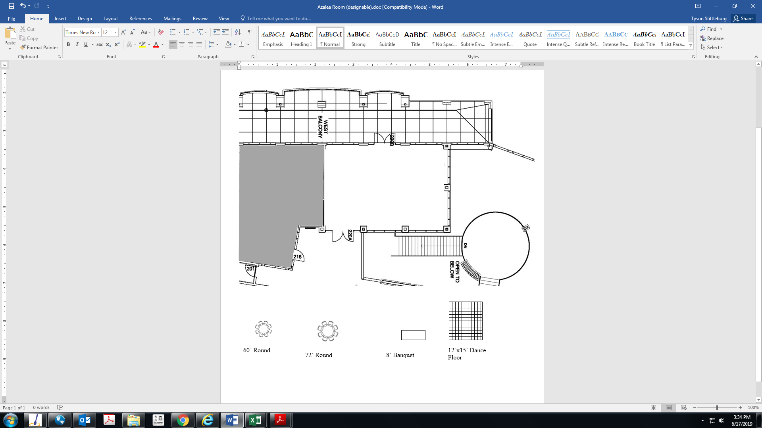Azalea Room

Right Click on these items to copy and paste. Then drag the item onto the diagram above

12’x15’ Dance Floor

8’ Banquet

60’ Round

Room Dimension

36 x 23