New Picture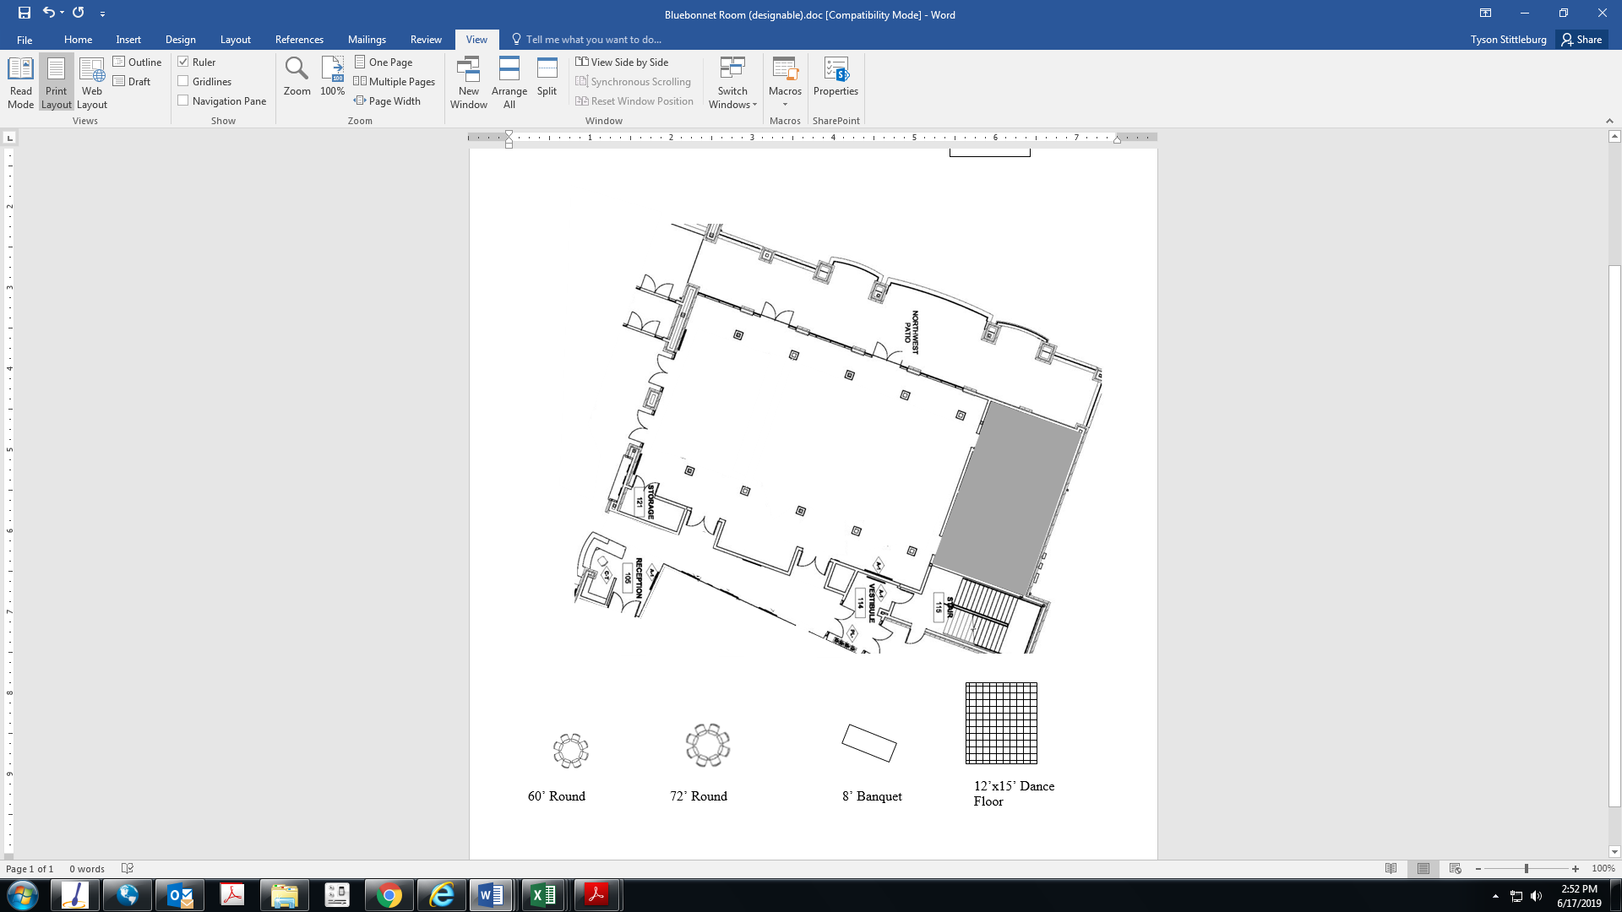Bluebonnet Room

Right Click on these items to copy and paste. Then drag the item onto the diagram above

60’ Round

8’ Banquet

15’x21’ Dance Floor

Room Dimension

42 x 63.5

Bluebonnet Room