New Picture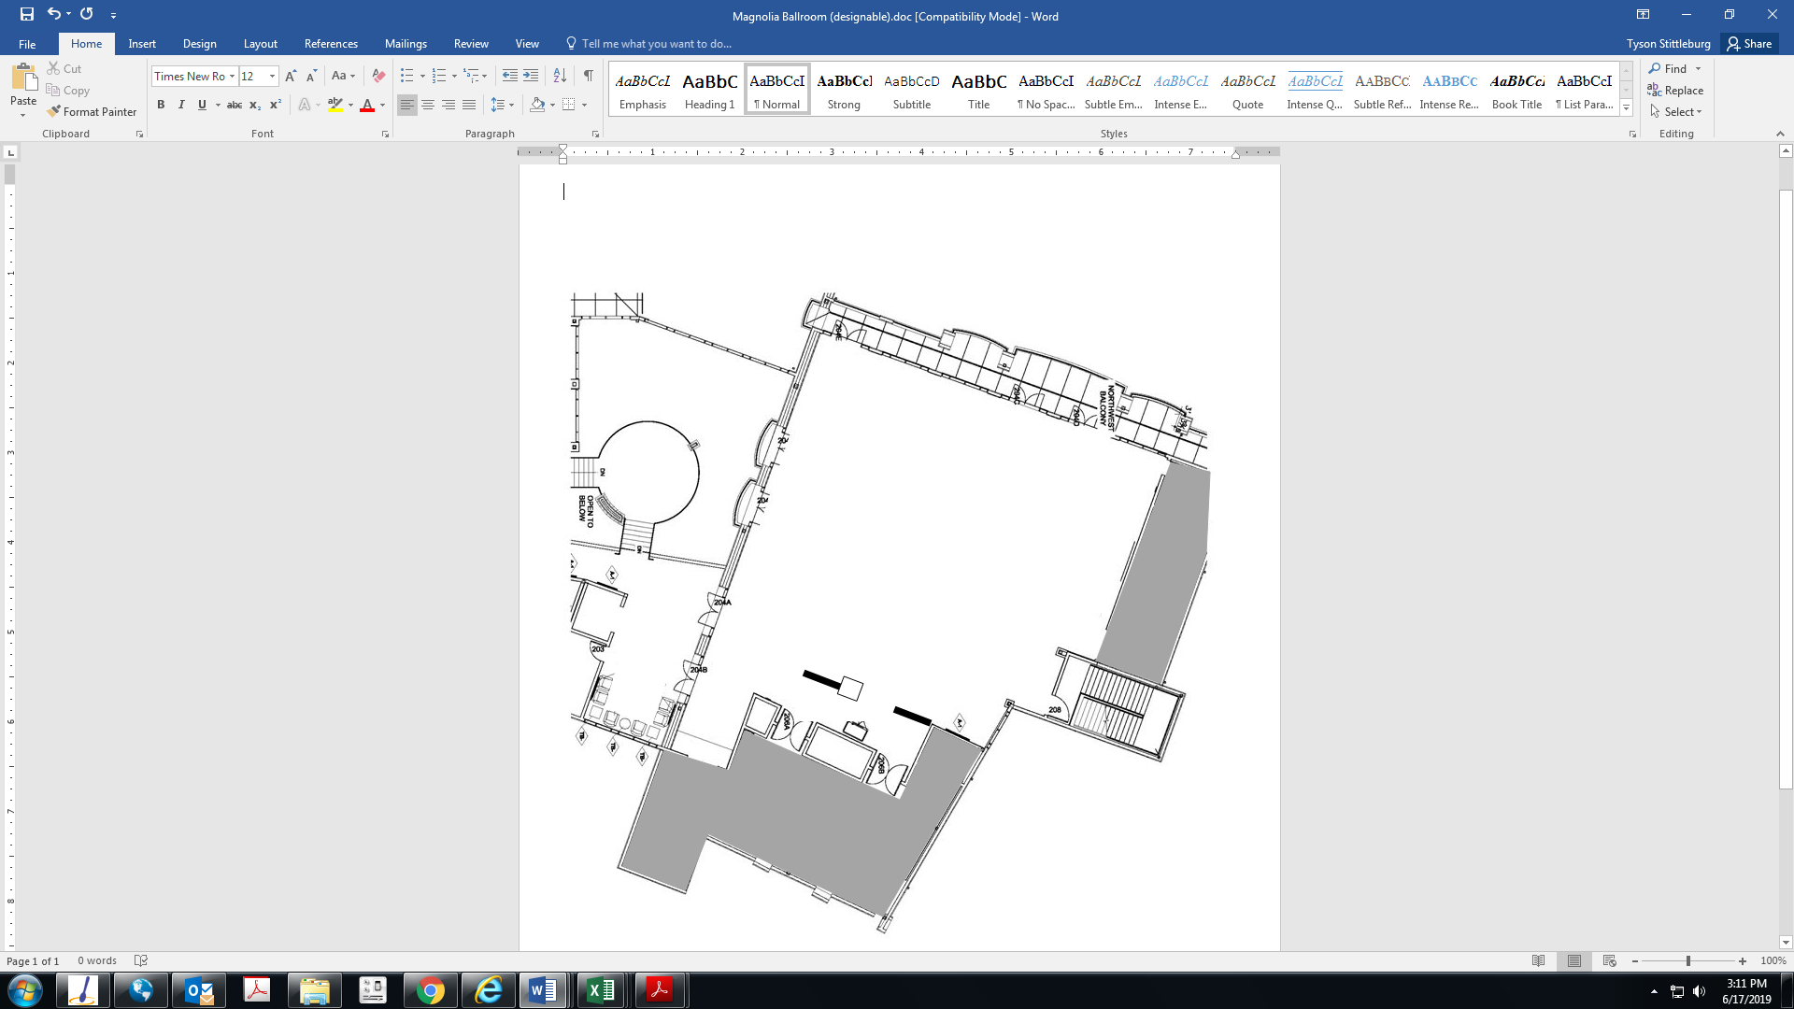Magnolia Ballroom

Right Click on these items to copy and paste. Then drag the item onto the diagram above

Room Dimension

70 x 62

21’x21’ Dance Floor

8’ Banquet

60’ Round